**Project Design Phase-II**

**AI-Powered Nutrition Analyzer For Fitness Enthusiasts**

**Team ID :PNT2022TMID17089**

**Team Leader :** SANTHIYA **Team member 1** :SHALINI **Team member 2 :** SNEHA **Team member 3 :** SRIDHARAN

**Requirement Analysis :**

* It will generate the diet plan as well as monitor the user’s health to classify the category of the disease and to create the diet plan. It will also reduce the cost of consulting the person nutritionist.
* The task of food detection/classification is not easy as it seems. All possible options related to the given Image.

1. Image classification, object detection, segmentation, face recognition.
2. Classification of crystal structure using a convolutional neural network

* Computer-Assisted Nutritional Recognize Food Images – In order to solve this issue, a brand-new Convolutional Neural Network (CNN)- based food picture identification system was created, as described in this study. We utilized our suggested strategy on two sets of actual food picture data.
* Here the user can capture the images of different fruits and then the image will be sent to the trained model. The model analyzes the image and detects the nutrition based on the fruits like (Sugar, Fiber, Protein, Calories, etc.)
* The Ultimate Workout at Home Solution This fitness AI software is designed with personalized training regimens for each individual. It began as “gym only software,” but has now improved its system to satisfy “at home fitness” expectations.
* You take a picture, dial in data such as whether you are eating breakfast or lunch and add a quick text label, and the app estimates the calorie content.

This software collaborated with IBM’s natural language capability to provide 24-hour assistance and dietary recommendations.

For Example:

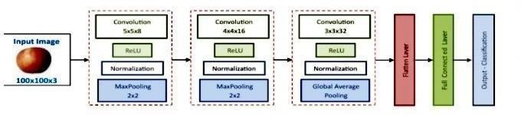

* The comparison of the proposed model with the conventional models shows that the results of this model are exceptionally good and promising to use in real-world applications. This sort of higher accuracy and precision will work to boost the machine’s general efficiency in fruit recognition more appropriately.
* A generic model for the dietary protein requirement (as with any nutrient) defines the requirement in terms of the needs of the organism,
* i.e. metabolic demands, and the dietary amount which will satisfy those needs, i.e. efficiency of utilization, thus: dietary requirement = metabolic demand/efficiency of utilization.